
Business Question and Visualization Report

Date | 02 November 2026
Team ID | NA
Project Name | Electric Vehicle Market Performance & Insights
Maximum Marks | 5 Marks

Visualization development refers to the process of creating graphical representations of data to facilitate understanding, analysis, and decision-making. The goal is to transform complex datasets into visual formats that are easy to interpret, enabling users to gain insights and make informed decisions. Visualization development involves selecting appropriate visual elements, designing layouts, and using interactive features to enhance the user experience. This process is commonly associated with data visualization tools and platforms, and it plays a crucial role in business intelligence, analytics, and reporting
Business Questions and Visualisation
The process involves defining specific business questions to guide the creation of meaningful and actionable visualizations in Tableau. Well-framed questions help in identifying key metrics, selecting relevant data, and building visualisation that provide insights.
Business questions answered by my EV Technology workbook:
1. What are the headline technical and sales figures of the EV market?
  - Visualization: KPI text table – 6 measures – sheet “EV Performance Snapshot”.
  - Scenario(s): 1, 2, 3
  - Insight: Total annual sales are 1,559.4 M units; an average EV has a 78.2 kWh battery and a 169.8 kW motor, uses 250.4 Wh per km, costs 2,085 USD a year to insure and needs 11.3 hours to charge on AC.
  - Screenshot:
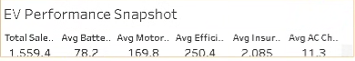

2. How is EV sales volume shared between market regions?
  - Visualization: Treemap – SUM(Annual Sales Units) by Market Region – sheet “Sales Share by Market Region”.
  - Scenario(s): 2
  - Insight: Every region holds about 14% of sales: South Asia (225.2 M units) and Latin America (224.7 M) are slightly ahead, Europe (218.8 M) is slightly behind – demand is balanced worldwide.
  - Screenshot:
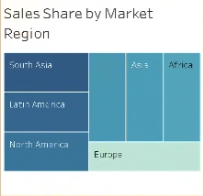

3. How have sales in each region changed over model years 2018–2026?
  - Visualization: Line chart – SUM(Annual Sales Units) by Model Year, one line per region – sheet “Sales Trend by Market Region”.
  - Scenario(s): 1, 2
  - Insight: All seven regional lines move closely together; total sales stay between 166.7 M and 178.0 M units per model year, with peaks for 2019 and 2024 models – growth is steady in every region.
  - Screenshot:
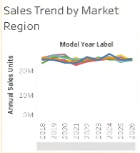

4. Which battery technologies sell most in each region?
  - Visualization: Heatmap – SUM(Annual Sales Units) by Battery Type × Market Region – sheet “Battery Type Sales by Region”.
  - Scenario(s): 2, 3
  - Insight: NMC and LFP are the darkest cells in every region (about 70–79 M units each), with NMC strongest in South Asia (78.5 M). Sodium-Ion and Solid-State are the lightest (15–23 M) – new chemistries are still small everywhere.
  - Screenshot:
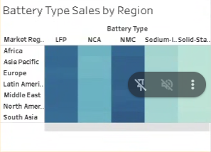

5. How large are the batteries in each vehicle category?
  - Visualization: Horizontal bar chart – AVG(Battery Capacity kWh) by Category – sheet “Battery Capacity by Category”.
  - Scenario(s): 1, 3
  - Insight: Electric Buses carry the biggest batteries (300.2 kWh), followed by Electric Trucks (225.1 kWh) and Pickup Trucks (125.2 kWh). Two-Wheeler Scooters need only 3.3 kWh.
  - Screenshot:
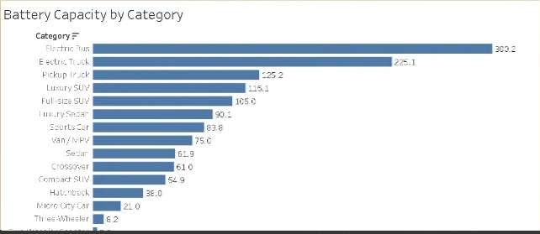

6. Which vehicle categories use the most energy per kilometre?
  - Visualization: Bar chart – AVG(Efficiency Wh per km) by Category – sheet “Energy Efficiency by Category”.
  - Scenario(s): 3
  - Insight: Electric Buses (1,159 Wh/km) and Electric Trucks (1,049 Wh/km) use far more energy per km than passenger cars (≈140–240 Wh/km), while Two-Wheelers use only 35 Wh/km.
  - Screenshot:
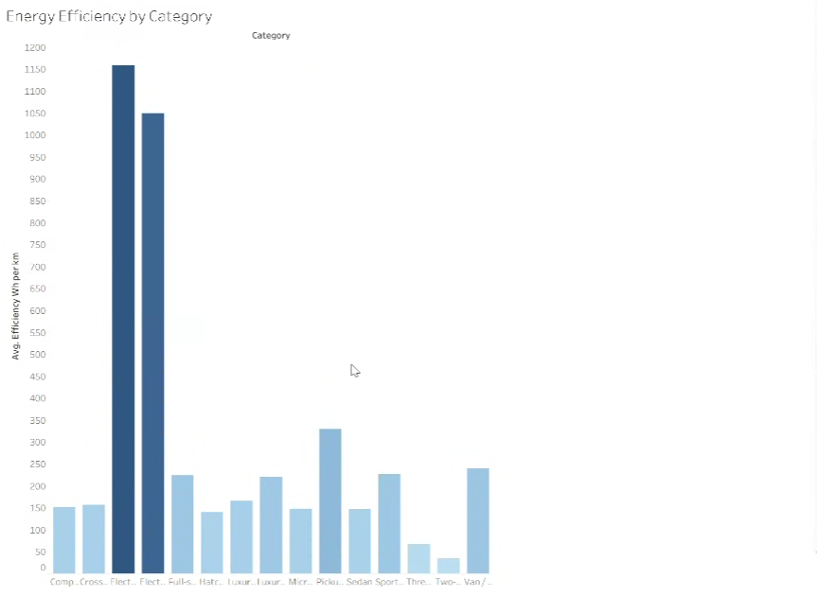

7. Does battery chemistry change AC charging time?
  - Visualization: Bar chart – AVG(AC Charge Time hr) by Battery Type – sheet “AC Charging Time by Battery Type”.
  - Scenario(s): 3
  - Insight: Average AC charging time is almost the same for every chemistry – about 11.2–11.3 hours (Solid-State 11.35 h, NCA 11.24 h). Charging time depends on battery size, not chemistry.
  - Screenshot:
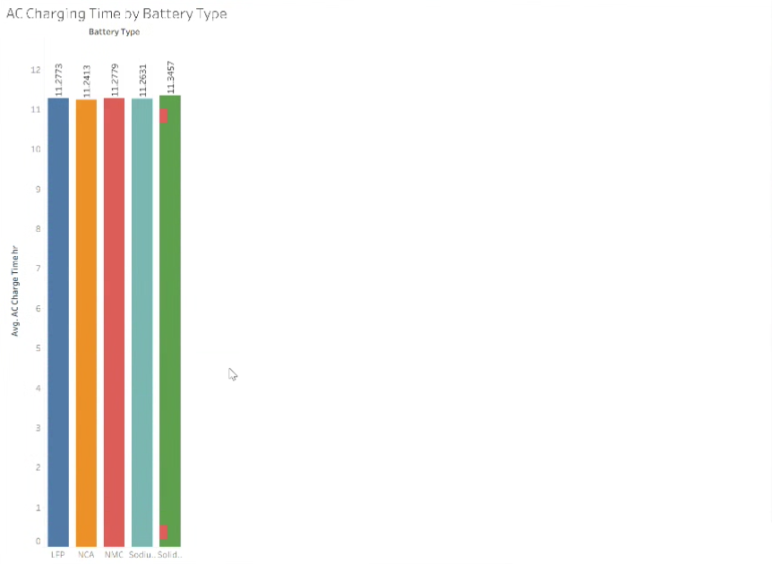

8. How does motor power differ between AWD, FWD and RWD?
  - Visualization: Horizontal bar chart – AVG(Motor Power kW) by Drivetrain – sheet “Motor Power by Drivetrain”.
  - Scenario(s): 1, 2
  - Insight: AWD vehicles have the most powerful motors (223.8 kW on average), about 54% more than FWD and RWD vehicles (145.3 kW each).
  - Screenshot:
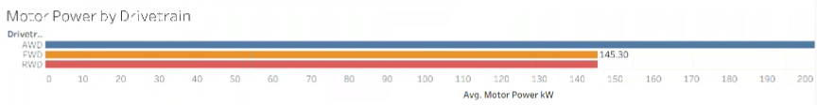

9. How is vehicle price related to yearly insurance cost?
  - Visualization: Scatter plot – AVG(Price USD) vs AVG(Insurance Cost USD Yearly) by Category – sheet “Price vs Insurance Cost”.
  - Scenario(s): 2
  - Insight: Insurance rises almost in a straight line with price (correlation 0.92): Two-Wheelers cost about 2,555 USD and 85 USD/yr to insure, while Electric Buses cost about 274,543 USD and 8,316 USD/yr.
  - Screenshot:
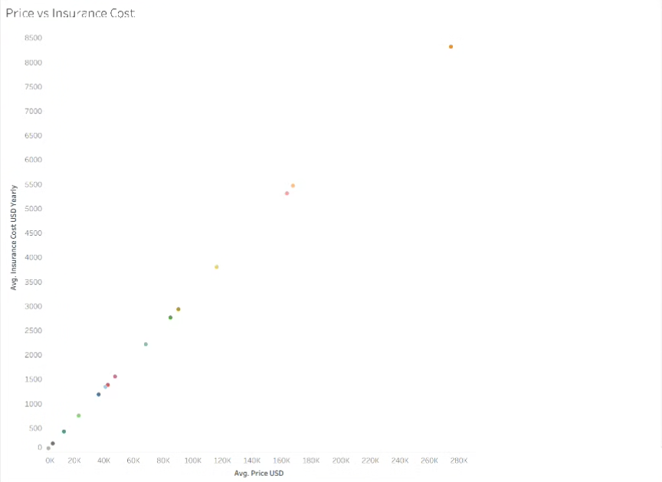

Total: 9 business questions and visualisations.

